AD LIFECYCLE ARTIFACT | External Design Document – V0.1  High Level Application Design
Application: Grid Messaging Service | Project Name: Communication between Grid and Non-Grid
 | Project Initiation Code: SMT
Author: Enterprise Architecture Team, Acxiom Corporation. | Project Code: SMT
 | Time Tracking Code: SMT
The External Design represents the high level functional specifications for your application based upon the approved business requirements.
2.01 - OVERVIEW 2
2.02 - FEATURE TRACEABILITY MATRIX 3
2.03 - DESIGN ALTERNATIVES 4
2.04 – EXTERNAL DESIGN (selected) 5
2.05 - DESIGN ASSUMPTIONS 8
2.06 - DESIGN LIMITATIONS 8
2.07 - DESIGN RISKS 8
2.08 - ARCHITECTURE IMPLICATIONS 9
2.09 – APPLICATION INTERFACE DESIGN MATRIX (required if other Applications are impacted) 10
2.10 – DATABASE / FILE DESIGN MATRIX (required if any database/files are added modified) 10
2.12 - TEST PLANNING GUIDELINES 11
2.13 - ERROR HANDLING 12
2.14 - NOTES 13
2.15 – EXTERNAL DESIGN SIGNOFF 14
2.16 - INTERNAL DESIGN (COMPONENT) MATRIX 15
2.17 - APPENDIXES 16

2.01 - OVERVIEW
The overview should provide a high level description of the design plan or modifications as they pertain to your application to address the business requirements for one specific business request (project, enhancement or maintenance effort). The overview should include references to any applications and functional areas that may be impacted by your design. This information should be 1-2 paragraphs and present an executive level summary of the business needs and the system development/modifications required by your application to meet those business needs.

The Syndicated Market Tracking solution is composed of a number of sub-systems which collaborate together to build various client deliverables. One key aspect of any such diverse environment is a strong integration strategy that provides a robust yet loosely-coupled collaboration framework. IRI has decided to implement an Enterprise Service Bus (ESB) that will provide a robust and dynamic platform which will provide a service oriented integration framework for all the sub-systems in the non-grid environment.

While ESB integration patterns are relatively well-known for monolithic sub-systems, they still need to be detailed out for Grid-based applications. This document will describe the high level architecture, interface details, common scenarios for integration of Grid-based applications with non-grid based applications via ESB.

2.02 - FEATURE TRACEABILITY MATRIX
This provides clear visibility and correlation between the features and the functional points that drive these features tying them to the use cases where they are mentioned

S No. | Feature Name | Requirement | Type

2.03 - DESIGN ALTERNATIVES

If multiple design options apply, each of those options needs to be identified and described, along with the pros and cons of each option.

Following is the recommended approach to solve grid and non-grid application integration problem.

Messaging Hive Service:
The Messaging Hive Service is an integration broker that will be hosted on the persistent hive on the Grid. A Persistent Hive is a set of nodes on the Grid that can be used to host long-running highly-available persistent services.
This Messaging Hive service will handle all communications between the Grid-based applications and the non-grid ESB.

Following are some of the advantages of the above deployment scenario.
  - There are no security implications as the service manages all communication.
  - A number of common services/policies/protocols can be hosted in this infrastructure instead of being part of every sub-system. This level of indirection can be handy in cases where global policies need to be applied across sub-systems.

Following diagram depicts the high-level view of the Messaging Hive Service for Grid Non-Grid communication:

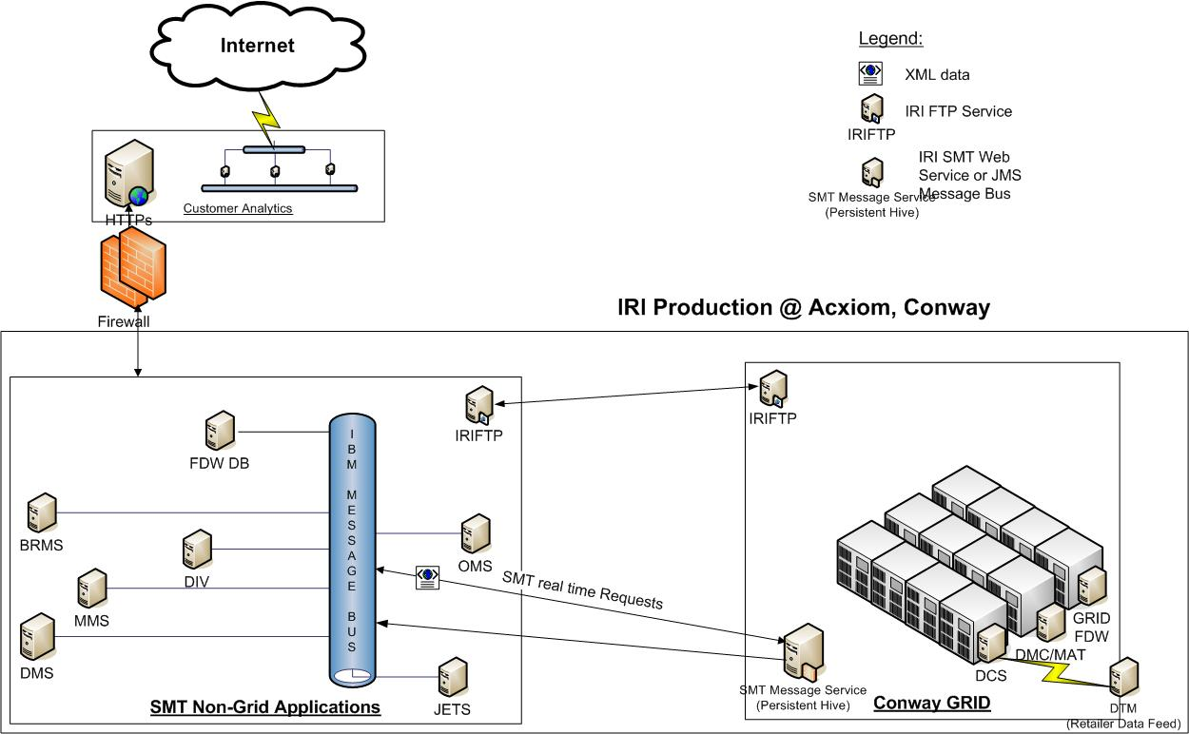

2.04 – EXTERNAL DESIGN (selected)
Provide a high level design that describes how the application will be developed or modified to meet the business requirements. This design can also be referred to as the functional specifications. Utilize whatever means are available to best present your design. This could take the form of Visio diagrams, DFD’s, process flows, logic flows, narratives, etc. This section should include the basic data requirements, application and network interface plans, screen layouts, report mock-ups, etc. as is pertinent to this project. There should be enough information provided here to allow representatives of the affected areas to approve and sign-off on your design.

All communications between the Grid and Non-Grid based sub-systems are inherently asynchronous. Sub-systems communicate with each other using XML messages over JMS or HTTP endpoints. In order for the Service Bus to identify the purpose and destination of any message each message will contain in its header the following attributes
- Message-Type: The Message-Type will uniquely identify the type of the message which will help the Service Bus determine the routing strategy for the message.
- Transaction /Correlation ID: The transaction or correlation id will define a global context under which the current message is being sent.
- Message ID: The message Id will uniquely identify the message for the sub-system.

Following are 3 main scenarios of messages exchanged between the ESB and the Grid-based applications.

1. Job Instrumentation Messages:

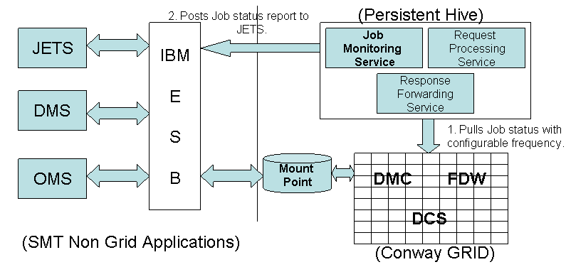
These are various job-instrumentation messages need to be provided to process monitors like JETS. Examples include heartbeat messages for each job, job initiation, job completion messages, utilization, throughput etc. There are 2 ways to approach this problem.

- Application Push: This approach places the burden of reporting instrumentation messages on the individual applications. This makes individual application design complicated and introduces a lot of redundancy.
- Job Monitoring Service Pull (Recommended): This approach relies on leveraging the core information that is gathered as part of the grid-scheduling infra-structure. An instrumentation service can be deployed on a persistent hive that merely pulls together job information every so often and posts it to the external monitoring service like JETS.

2. Request Messages:
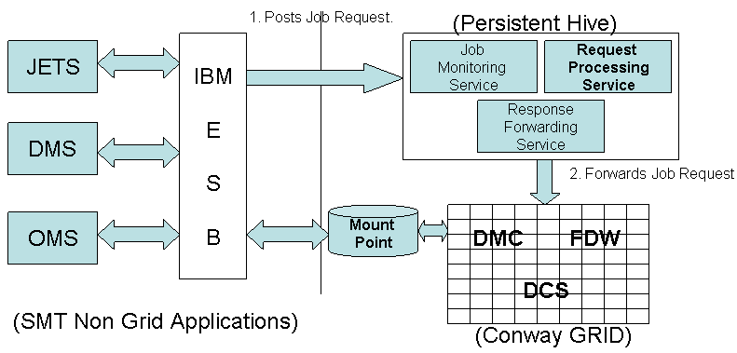

Service request messages typically are of two types:
- Job Invocation Requests: These are requests that result in various Grid-based sub-system job flows being scheduled for execution. The control files for these jobs can either be embedded in the request itself or copied to a well-known shared landing area on the grid. There are currently 2 ways jobs will be invoked on the Grid
- Have the orbiter/Grid scheduler check file arrival i.e. the status quo.
- Provide a real time job-scheduling service interface that can be directly invoked by the job-invocation service.

- Ad hoc query request: The persistent hives can also host stateless services that can provide ad-hoc query capabilities to external applications. An example of this would be data-mods type queries to report all updates on a particular day.

These types of messages will be handled by the Request Processing Service. Based on the Message type specified in the request, the request processing service will invoke the appropriate jobs. In UPCSel example there will be a C++/PERL/Java job will be called from service. As these are typically real-time in nature, existing Harvester component may not be suited for invocation from Service. The Request processing service will maintain a service directory that stores a request type to job type mapping.

3. Response Messages:
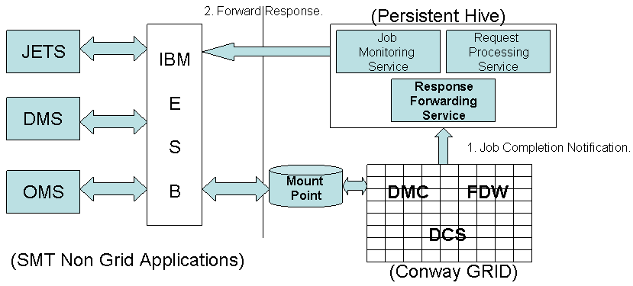

Response messages are typically transaction specific success/error messages that need to be routed to the appropriate destinations.
These types of messages will be handled by a Response Forwarding Service. The same strategy as employed with request messages will be employed in this regard.
Based on the Message type the appropriate service destination needs to be determined and the message will be routed to that destination. The message type to service mapping should be queried from the ESB orchestration mechanism or alternatively a service directory can be maintained on the persistent hive.

2.05 - DESIGN ASSUMPTIONS

- All sub-system interactions follow a service-oriented model i.e. xml-based request/response message interfaces.
- The ESB and the Grid scheduler provide a transactional job-invocation environment i.e. message post and receive operations on the ESB follow the ACID properties. Similarly, job scheduled/file arrival on the grid scheduler will also follow ACID properties.

2.06 - DESIGN LIMITATIONS

To be documented.

2.07 - DESIGN RISKS

- Message indirection duplicates some of the functionality that is provided by the ESB infrastructure i.e. naming, service directory. (This can be circumvented by having federated naming contexts between the ESB and the persistent hive).

- There is an added layer added to all interactions between the grid based applications and the outside world.

2.08 - ARCHITECTURE IMPLICATIONS
Network capacity, DASD capacity, performance, and any other design implications that may or will have an impact on the underlying platform architecture supported by ITO need to be listed and articulated. This information should be run by ITO and the Architecture Team to ensure significant design enhancements are approved, and that your design falls within standards for the Enterprise Application Architecture (EAA).

- The message flow between the Grid and Non-Grid applications should be asynchronous.
- Each transaction should have a unique id that is relevant across all the sub-systems that contribute to the processing of the transaction. This can be implemented by either leveraging native services provided by the ESB or by creating a custom global-uuid implementation.
- Message delivery should be guaranteed although this may not necessarily be true for certain kinds of messages e.g. I’m Alive type messages.
- The non-grid applications should only have to specify the kind of job that needs to be invoked and the inputs required thereof without knowing about the implementation details i.e. executable location, no of nodes etc.
- A Naming service needs to be implemented that can allow services to be located on the grid.
- Performance SLA for the ESB integration for all these scenarios will need to be worked out.
- The Authentication and Authorization framework will have to be set-up around this.
- Implications for 32/64 bit node management need to be analyzed.

2.09 – APPLICATION INTERFACE DESIGN MATRIX (required if other Applications are impacted)
This provides a cross-reference of the application interfaces that will need to be established or modified. Each new or modified interface requirement should be listed on a separate line in the table. The addendum should be used to detail the interface specifics. This should contain all dependencies to other systems, sub-systems, files and databases that need to be modified.

2.10 – DATABASE / FILE DESIGN MATRIX (required if any database/files are added modified)
This provides a cross-reference of the files and databases that will need to be established or modified. Each file / database that needs to be modified or created should be listed on a separate line in the table.

2.12 - TEST PLANNING GUIDELINES
Identify areas to focus on when creating test plans. Should incorporate areas of risk (as identified in section 2.07). Identify key inputs and upstream/downstream processing that should be added to test planning and preparation.

2.13 - ERROR HANDLING
Include automated and manual procedures used to handle contingencies. Document any changes to internal/external error handling routines including event-handling for exceptions and error diagnostics/reporting.

2.14 - NOTES
This section shall contain any general information that aids in understanding this Document (e.g., background information, glossary, rationale). This section shall include an alphabetical listing of all acronyms, abbreviations, and their meanings as used in this document and a list of any terms and definitions needed to understand this document.

2.15 – EXTERNAL DESIGN SIGNOFF
This section should list each functional area and representative that needs to approve the External Design in order for AD to proceed with the ‘Build’ process (internal design, coding, testing). Executive sponsors, project managers, ITO, representatives of affected application and User functional areas, etc. should be included

The functional areas listed below are examples. Add and delete as appropriate.

Signoff - Name | Signature – EMAIL Approval | Functional Area | Signoff Date

2.16 - INTERNAL DESIGN (COMPONENT) MATRIX
This provides a cross-reference between this External Design and the modules (components) that will need to be created or modified. Each affected module should be listed on a separate line in the table. This section should list every new or modified component of this application that will be required for the implementation of this project in production. This would include procedures, scripts, programs, executables, file structures, etc. For executables, you need to list the individual components of the executable that are modified for this project. Even modules that only require re-compiles with no code changes should be included.

Component | Version | Component Description | Type | Primary Design Changes (brief)

2.17 - APPENDIXES
Appendixes may be used to provide information published separately for Convenience in document maintenance (e.g., charts, classified data). As applicable, each appendix shall be referenced in the main body of the document where the data would normally have been provided. Appendixes may be bound as separate documents for ease in handling. Appendixes shall be lettered alphabetically (A, B, etc.).

